Running Ollama Locally with Python

OLLAMA WEBSITE: https://ollama.com/download

Process 1: Windows (Ollama + Python)
Step 1: Install Ollama
- Download Ollama for Windows from the official Ollama website.
- Run the installer and complete the setup.
- Open Command Prompt / PowerShell and verify installation:
ollama --version

Step 2: Pull a Model
ollama pull llama3
ollama list
Step 3: Confirm Ollama Server
Ollama automatically starts a local server at: http://localhost:11434
If it is not opening, copy paste the below onto your web browser
http://localhost:11434
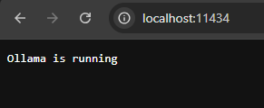
(please look at Appendix for easier understanding of step 2 & 3)
Process 2: Linux (Ollama + Python)
Step 1: Install Ollama
curl -fsSL https://ollama.com/install.sh | sh
ollama --version

Step 2: Pull a Model
ollama pull llama3

Step 3: Ensure Ollama Service Is Running
ollama list
Server runs at:
http://localhost:11434
(If it is not opening, copy paste the below onto your web browser
http://localhost:11434 )
(please look at Appendix for easier understanding of step 2 & 3)

Process 3: macOS (Ollama + Python)
Step 1: Install Ollama
- Download Ollama for macOS from the official website.
- Install and launch Ollama.
- Verify:
ollama --version
Step 2: Pull a Model
ollama pull llama3
Step 3: Confirm Local Server
ollama list
Server runs at:
http://localhost:11434
(If it is not opening, copy paste the below onto your web browser
http://localhost:11434 )

(please look at Appendix for easier understanding of step 2 & 3)

Appendix: FOR EASIER UNDERSTANDING (A pictorial explanation is given)

STEP 2. Once that you had installed the OLLAMA on your system
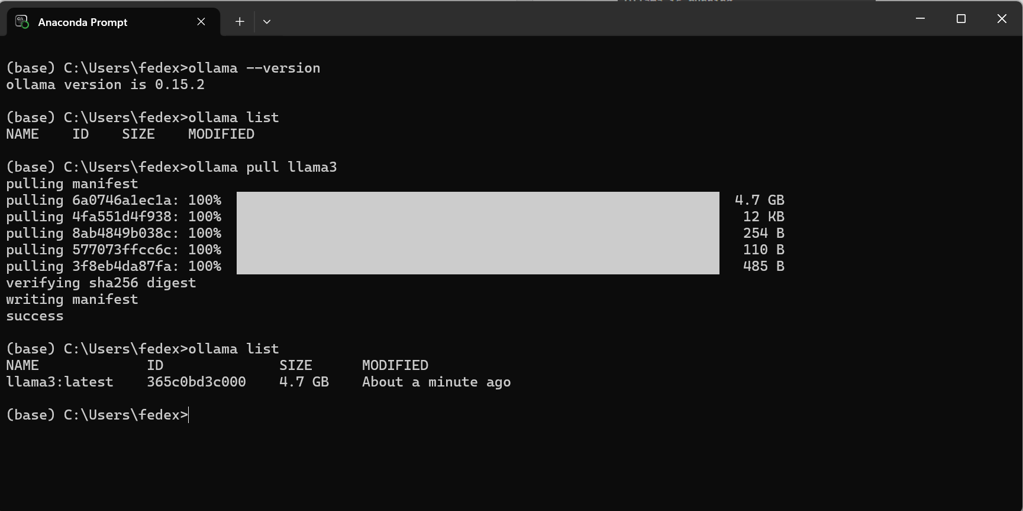

Type ollama pull llama3 and press Enter
Type ollama list and Press Enter
Type ollama –version and Press Enter
Type ollama list and press enter, you should see a model named llama3:latest

STEP 3: Checking whether the installation is correct. Copy and paste the http://localhost:11434 onto your web browser, you should be able to see this
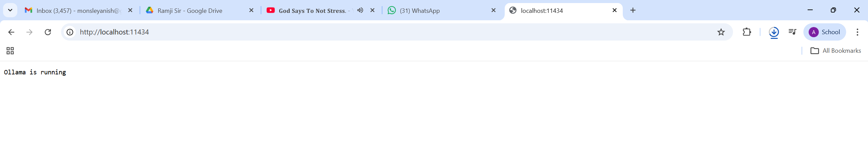
Which means that OLLAMA is running successfully.

